IMAGEPROCESSINGASSIGNMENT

Submitted By:

Srishti Singal 101503229

Tanvir Kaur 101503231

Vedika Bhutani 101503236

Vinayak Arora 101503244

Batch: COE11

1.Convertagrayscaleimagetobinary.

a=imread('lena.jpg');

t=input('Enterthreshold');[r,c]=size(a);

b=zeros(r,c);fori=1:r

forj=1:cif(a(i,j)>t)

b(i,j)=1;else

b(i,j)=0;end;

end;end;

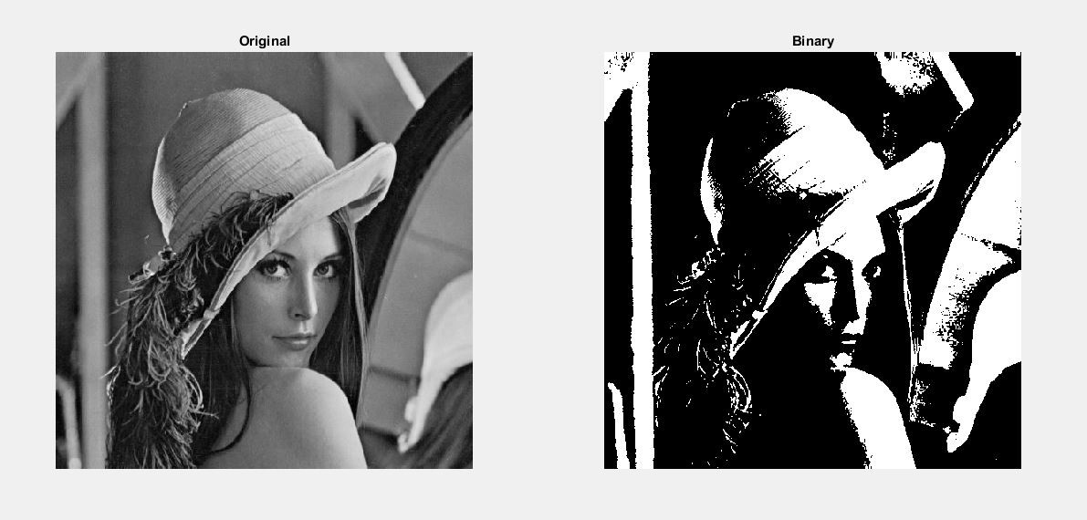subplot(1,2,1),imshow(a),title('Original');subplot(1,2,2),imshow(b),title('Binary');

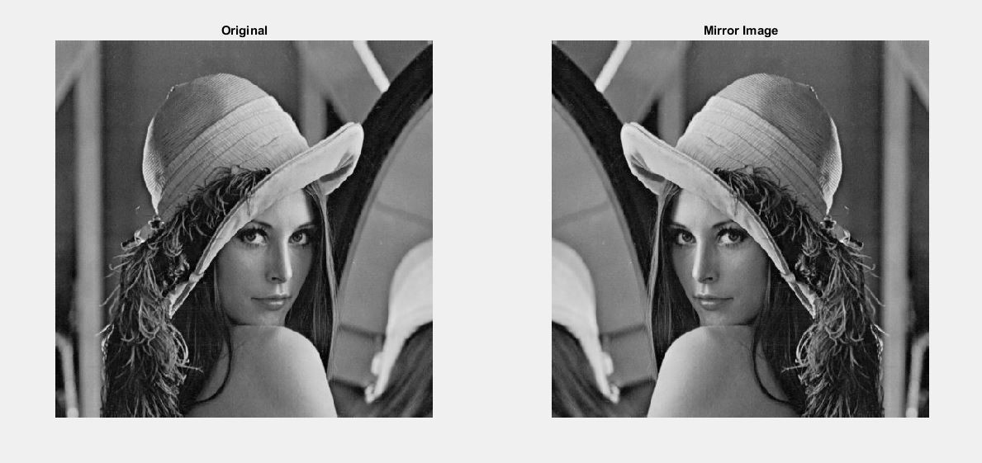

2.MirrorImage

a=imread('lena.jpg');[r,c]=size(a);img=zeros(r,c);

fori=1:rk=c;

forj=1:cimg(i,k)=a(i,j);k=k-1;

end;end;

subplot(1,2,1),imshow(a),title('Original');subplot(1,2,2),imshow(uint8(img)),title('MirrorImage');

3.LeftRotate

a=imread('lena.jpg');[r,c]=size(a);img=zeros(r,c);

fori=1:rforj=1:c

img(j,i)=a(i,j);end;

end;subplot(1,2,1),imshow(a),title('Original');

subplot(1,2,2),imshow(uint8(img)),title('RotatedImage');

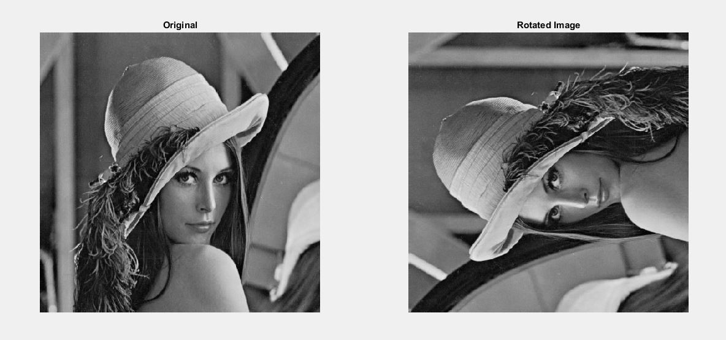

4.RightRotate

a=imread('lena.jpg');[r,c]=size(a);img=zeros(r,c);

k=c;

fori=1:rforj=1:c

img(j,k)=a(i,j);end;

k=k-1;end;

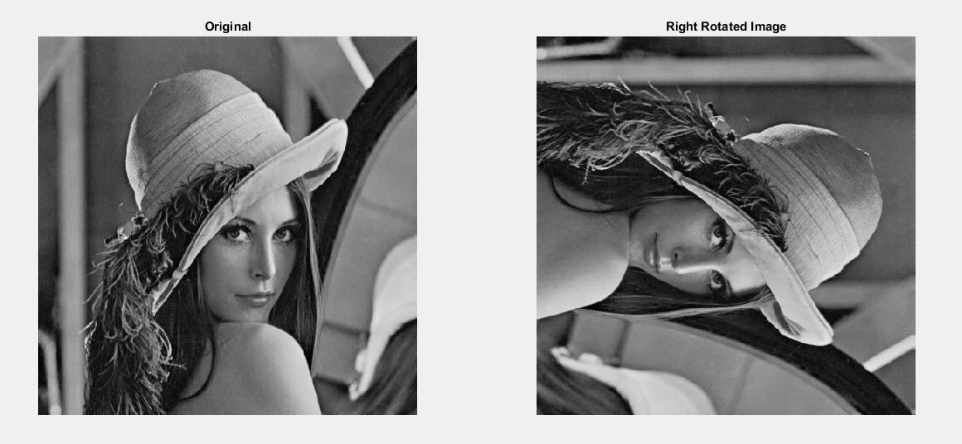subplot(1,2,1),imshow(a),title('Original');subplot(1,2,2),imshow(uint8(img)),title('RotatedImage');

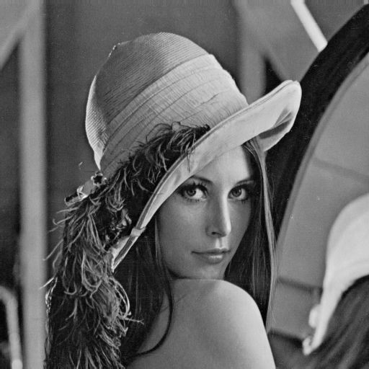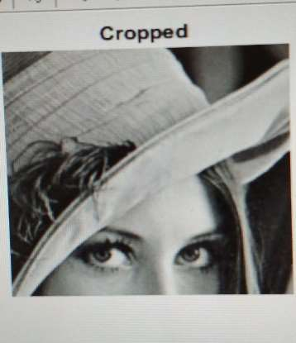

5. CropImage

a=imread('lena.jpg');[r,c]=size(a);

img=zeros(200,200);d=1;

fori=100:300k=1;

forj=200:400

img(d,k)=b(i,j);k=k+1;

end;

d=d+1;end;

imshow(uint8(img)),title(‘Cropped’);

6.ResizeImage

a=imread('lena.jpg');

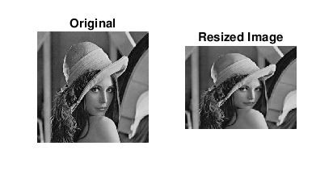b=imresize(a,[150,200]);subplot(1,2,1),imshow(a),title('Original');subplot(1,2,2),imshow(uint8(b)),title('ResizedImage');

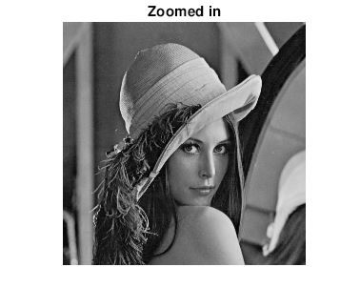

7.ZoominusingInterpolation

a=imread('lena.jpg');[r,c]=size(a);

b=zeros(2*r,2*c);m=1;

n=1;

fori=1:rn=1;

forj=1:c

b(m,n)=a(i,j);b(m,n+1)=b(m,n);n=n+2;

end

forj=1:2*cb(m+1,j)=b(m,j);

endm=m+2;

end

imshow(uint8(b)),title("Zoomedin");

OUTPUT:Sizeofoutputimageis1024X1024whensizeoforiginalimagewas512X512.

8.Shrinkusinginterpolation

A=imread('lena.jpg');

f=input('Entertheshrinkingfactoroftheimage:');s=size(A);

s1=s/f;k=1;l=1;

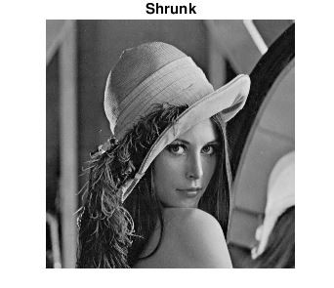

fori=1:s1forj=1:s1

B(i,j)=A(k,l);l=l+f;

endl=1;k=k+f;

endimshow(uint8(B)),title('Shrunk');

OUTPUT:Outputimageis256X256whileinputimagewas512X512.

9.Negativefunction

a=imread('lena.jpg');[r,c]=size(a);img=zeros(r,c);

fori=1:rforj=1:c

img(i,j)=255-a(i,j);end;

end;subplot(1,2,1),imshow(a),title('Original');

subplot(1,2,2),imshow(uint8(img)),title('FlippedImage’);

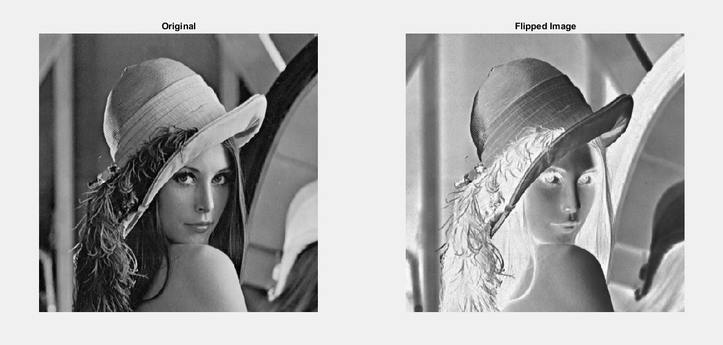

10.LogarithmicFunction

a=imread('lena.jpg');[r,c]=size(a);d=double(a);b=zeros(r,c);

fori=1:r

forj=1:c

b(i,j)=40*log(1+d(i,j));end

endsubplot(1,2,1),imshow(a),title('Original');

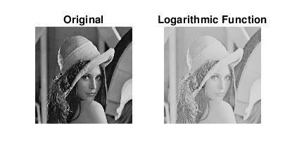subplot(1,2,2),imshow(uint8(b)),title('LogarithmicFunction');

11.PowerFunction

a=imread('lena.jpg');img=double(a);[r,c]=size(a);

fori=1:rforj=1:c

fin=power(img(i,j),0.2);end

endsubplot(1,2,1),imshow(a),title('Original');

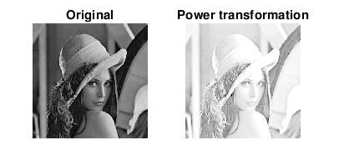subplot(1,2,2),imshow(uint8(b)),title('Powertransformation');

12. Gaussian Filter

A=imread(‘lena.jpg’);

B==imgaussfilt(A,3,’FilterSize’,[7,7]);

imshow(A);

imshow(B);

13. Mean Filter

A=imread(‘lena.jpg’);

H=fspecial(‘average’);

B=imfilter(‘A,H’);

imshow(B);

14. Median Filter

A=imread(‘lena.jpg’);

B=ordfilt2(A,5,ones(3,3));

imshow(B);

15. Minimum Filter

A=imread(‘lena.jpg’);

B=ordfilt2(A,1,ones(3,3));

imshow(B);

16. Maximum Filter

A=imread(‘lena.jpg’);

B=ordfilt2(A,9,ones(3,3));

imshow(B);

17. Bitslicing

a=imread('img.jpg');a=rgb2gray(a);

a=uint8(a);t_img=a;

si=size(a);img1=zeros(si);fork=1:8

fori=1:si(1)forj=1:si(2)

img1(i,j)=mod(t_img(i,j),2);t_img(i,j)=t_img(i,j)/2;

endend

subplot(2,4,k);imshow(img1);

end

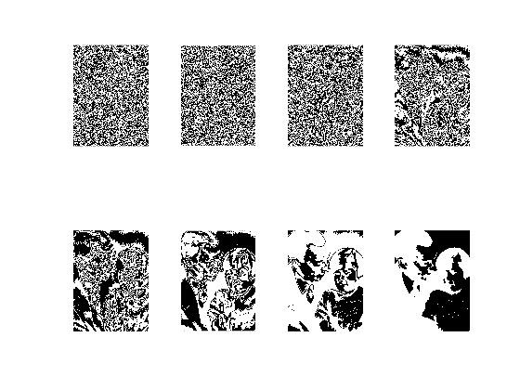

18. Histogramequalization

a=imread('img.jpg');a=rgb2gray(a);

a=uint8(a);si=size(a);L=256;b=zeros(L,1);fori=1:si(1)

forj=1:si(2)b(img(i,j)+1)=b(img(i,j)+1)+1;

endendsum=0;fori=1:L

sum=sum+b(i);end

b=double(b);pr=zeros(L,1);pr(1)=b(1)/sum;fori=2:L

pr(i)=b(i)/sum;pr(i)=pr(i)+pr(i-1);

end

fori=1:L

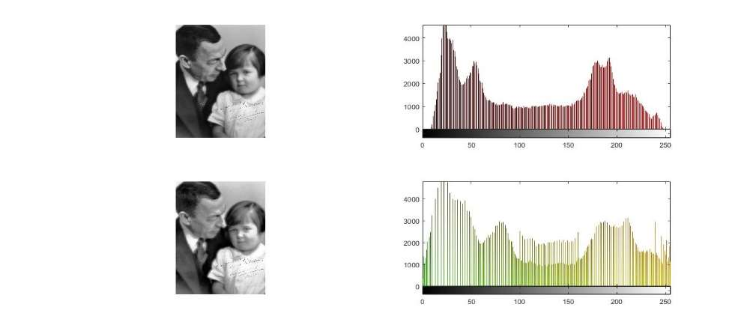

pr(i)=(L-1)*(pr(i));pr(i)=round(pr(i));

endimg1=zeros(si);fori=1:si(1)

forj=1:si(2)img1(i,j)=pr(img(i,j)+1);

endend

img1=uint8(img1);subplot(2,2,1);imshow(img);subplot(2,2,2);imhist(img);subplot(2,2,3);imshow(img1);subplot(2,2,4);imhist(img1);

19. NoiseAddition

a=imread('lena.jpg');

j=imnoise(a,'gaussian');

subplot(1,2,1),imshow(a),title('OriginalImage');

subplot(1,2,2),imshow(j),title('NoiseIntroduction');

